**Web Systems Lab Submission 01**  
**Members:** Mark Anthony Villiones

:Ahmidserhan Halon

:Rendrick Marquez

**Date:** September 24, 2023

**System Name :** FashionFusion Web Wardrobe

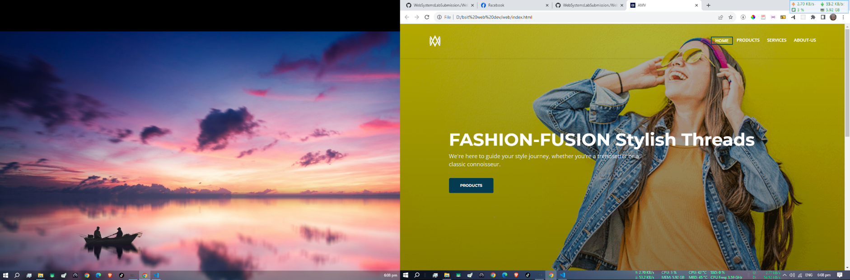

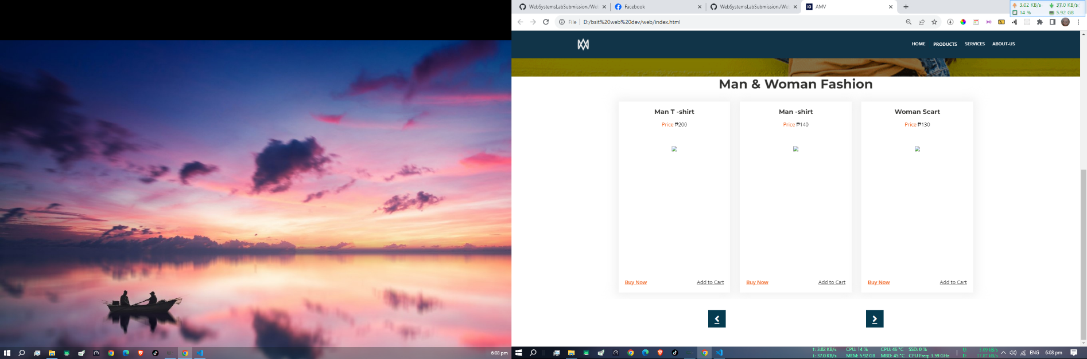

**Functionalities/Feature:**

1. **User Authentication/Accounts**: Allow users to create accounts where they can save their shipping information, view their order history, and save their favorite products.
2. **Product Catalog**: Display products with high-quality images, detailed descriptions, and prices. Allow users to filter and sort products by various attributes like size, color, price, etc.
3. **Shopping Cart**: Allow users to add products to a shopping cart and make changes like updating the quantity or removing items.
4. **Search Functionality: Search bar that allows user to search for products.**
5. **Contact Form**: Include a form where users can send inquiries or report issues. To help provide better customer service.